

CallDr Central Provider Role

Contents

The Provider Role 2

Log In to CallDr Central 2

Navigate to the Home Screen 2

Trade Calls with Another Provider 3

Request a Trade 3

Request a Trade with a Specific Provider 3

Request a Trade using Give Away A Day 5

Cancel or Check the Status of an Outgoing Trade Request 7

Accept or Decline a Trade Request 7

Edit Provider Profile 8

Change Password 10

View User Profile 10

Tips, Tricks and Contacting Us. 12



Fractal OnCall Solutions, LLC.

Mobile Medical Collaboration Solutions

2440 E. Tudor #240 Anchorage, AK 99507

# The Provider Role

The Provider role allows a provider to view an upcoming schedule, trade shifts with another provider in the same specialty, and edit personal provider contact information.

## Log In to CallDr Central

Follow these steps to log in to CallDr Central:

1. In any web browser, navigate to CallDr Central. The system displays the **Login** screen:

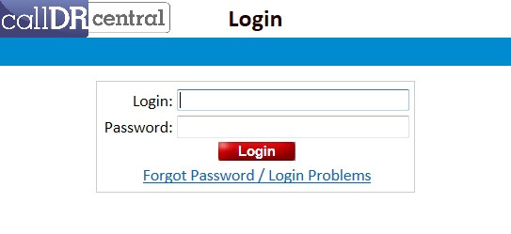

1. Enter username in the **Login** field and password in the **Password** field and click **Login.** 
   * + A successful login takes the user to the home page for the user’s role.
     + An unsuccessful login results in the **Invalid Login** message.

1. For help with the login process, click the **Forgot Password / Login Problems** link to submit a question through the **Send CallDr Central Feedback Email** dialog box.

## Navigate to the Home Screen

The **Home** screen for a Provider user defaults to that provider’s upcoming EMTALA schedule and trade activity:

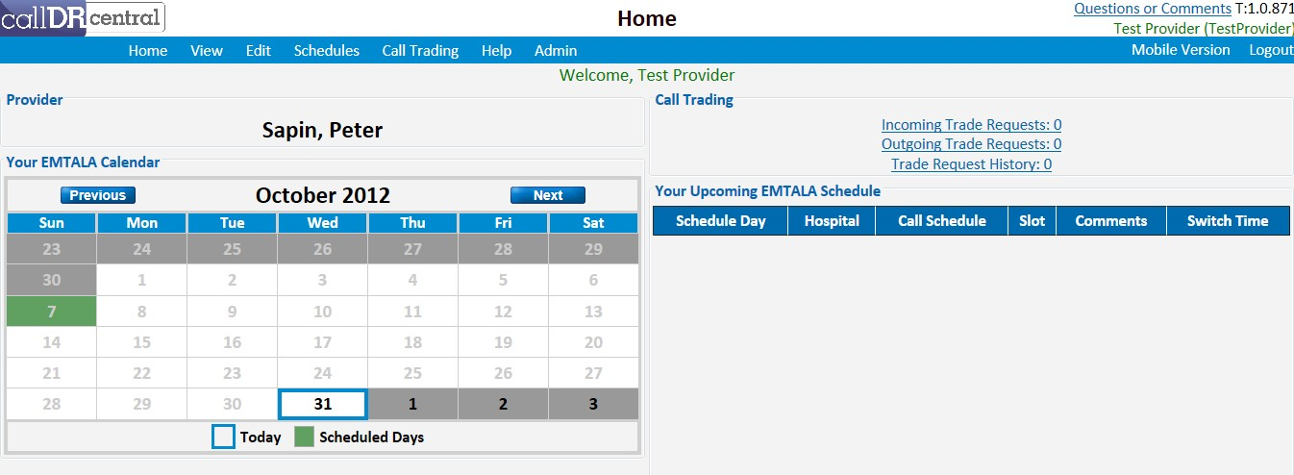

* + **Call Trading**: Contains links to **Incoming Trade Requests**, **Outgoing Trade Requests**, and the user’s **Trade Request History**.
  + **Your EMTALA Calendar**: Displays a monthly calendar view with the user’s scheduled EMTALA shifts highlighted in green.
  + **Your Upcoming EMTALA Schedule**: Displays a list of the user’s upcoming EMTALA shifts.

To return to the Home screen after navigating to another screen, click **Home** on the menu bar.

## Trade Calls with Another Provider

Call Trading allows a provider to request a trade, accept a trade request, or view trade history.

### Request a Trade

A provider can request an EMTALA shift trade by asking a specific provider to trade or by broadcasting an available shift to multiple providers using the **Give Away A Day** feature.

### Request a Trade with a Specific Provider

Follow these steps to request an EMTALA shift trade:

1. On the **Call Trading** menu, click **New Request.** The system displays the **Call Trading** screen, defaulted to the **Request Trade** tab:

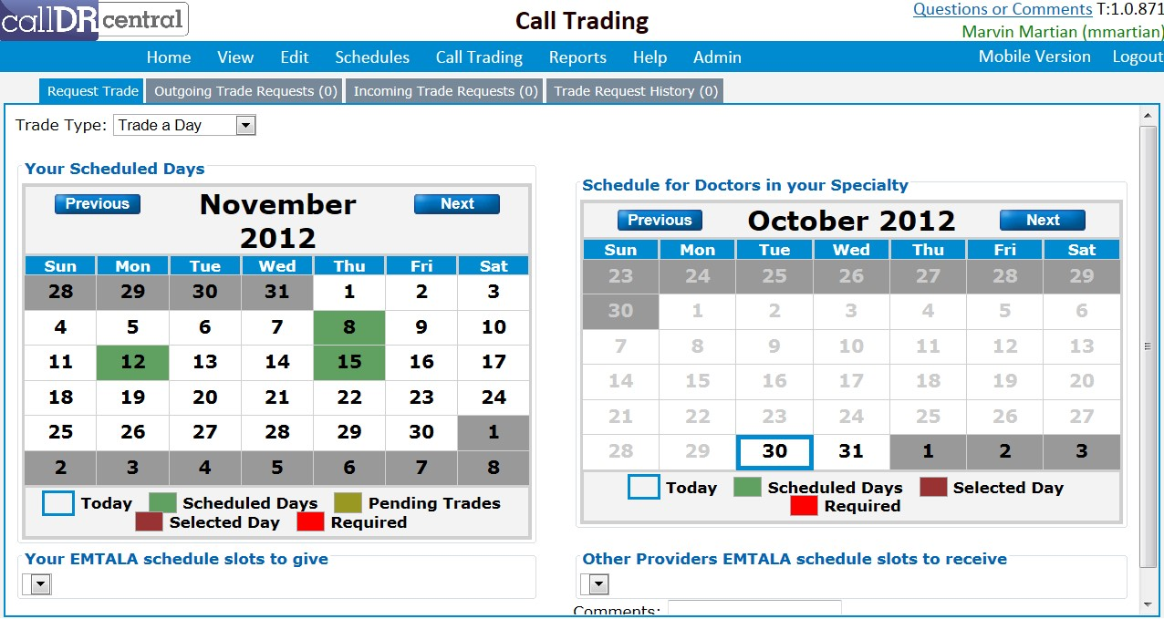

1. Select **Trade a Day** from the **Trade Type** dropdown list to trade a shift with another provider.
2. On the **Your EMTALA Calendar**, select the scheduled day to trade. Scheduled days are highlighted in green.
3. After a scheduled day is selected, the day turns red and the **Your EMTALA schedule slots to give** section displays:

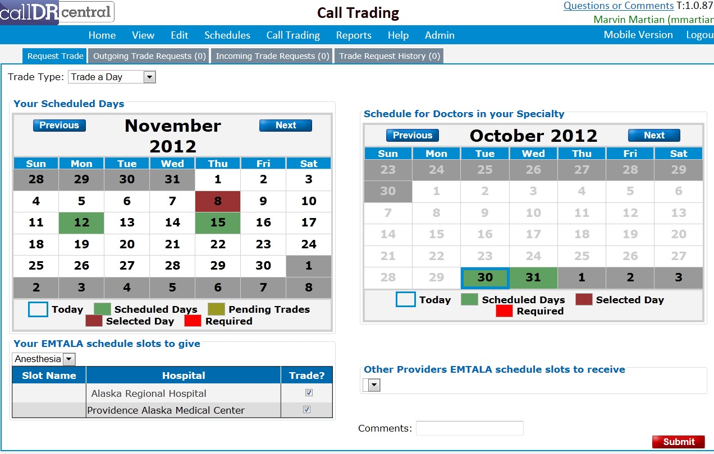

1. The call schedule(s) for which you are scheduled are listed in a drop-down menu. Select the call schedule that contains the slot you want to trade; the table underneath the drop-down will update to display the slots you are scheduled for on that day.
2. Check the slots you want to trade.
3. On the **Schedule for Doctors in your Specialty** calendar, select the scheduled day for the desired EMTALA shift. Only days highlighted in green can be selected.

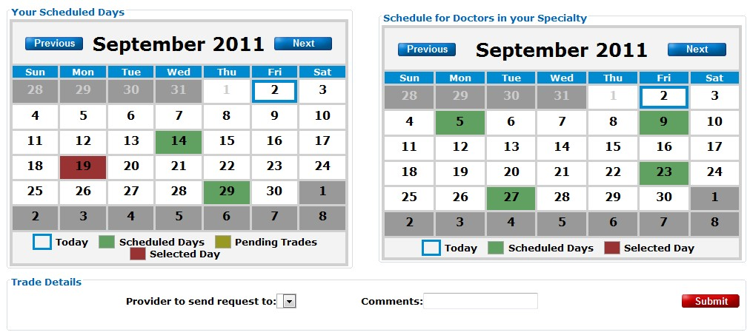

1. The **Other Providers EMTALA schedule slots to receive** section will display, showing available provider(s) for that day in a drop-down menu:

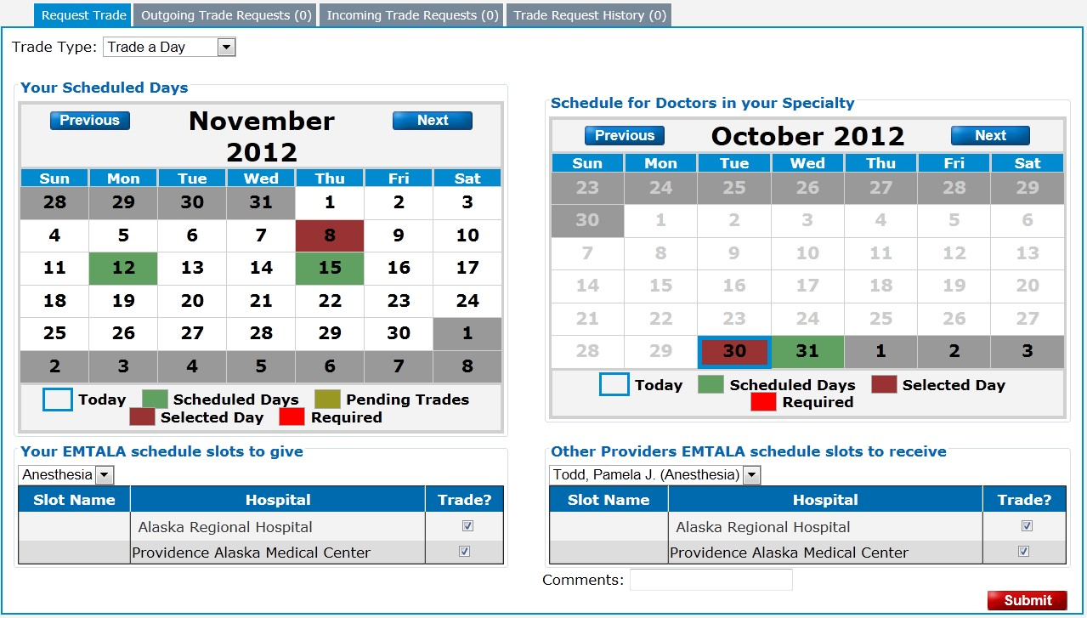

1. The table under the provider drop-down will update to show the slots the provider is assigned to.

Select a provider and check the slot(s) you would like to receive in trade.

1. Use the **Comments** box to add additional comments if desired and click **Submit**. The system displays a confirmation that the request was sent:

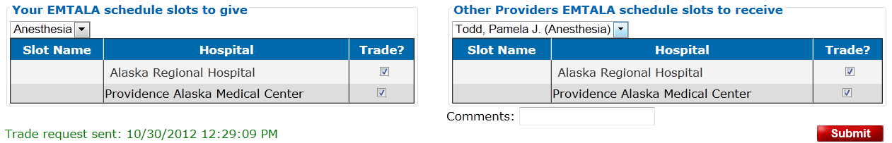

### Request a Trade using Give Away A Day

Follow these steps to request an EMTALA shift trade by broadcasting an available shift to multiple providers using the **Give Away A Day** feature:

1. On the Call Trading menu, click **New Request**. The system displays the **Call Trading** screen, defaulted to the **Request Trade** tab.
2. Select **Give Away a Day** from the **Trade Type** dropdown list. The system removes the **Schedule for Doctors in your Specialty** calendar and replaces it with the **Trade Details** pane:

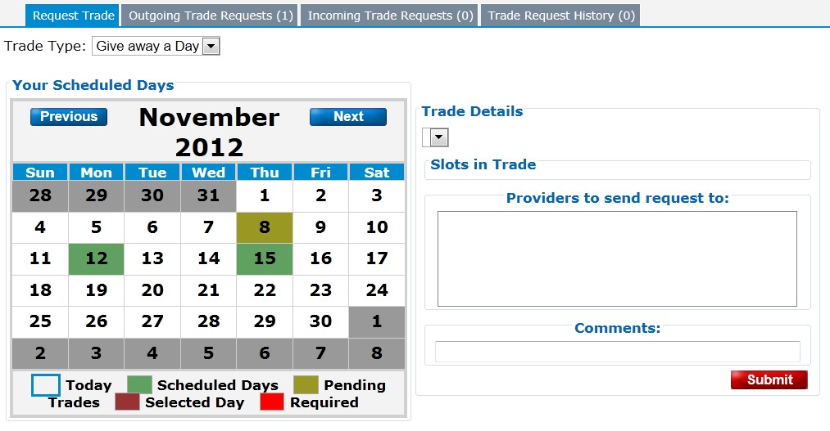

1. On the **Your Scheduled Days** calendar, select the scheduled day to give away. The system populates **Trade Details** to allow you to select from your assigned call schedule(s) on that day and verify the slots you want to give away. The **Providers to send request to** populates to show providers in the selected call schedule:

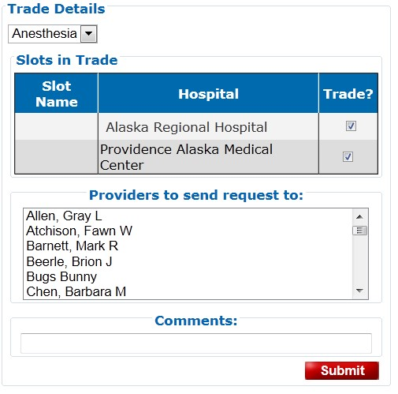

1. To select all of the providers in the list, click the first provider’s name, press and hold the **Shift** key, and click the last provider’s name. To select only certain providers, press and hold the **Ctrl** key while clicking those providers’ names. Enter optional comments and click **Submit** to send the request.

The system sends the selected providers a trade request email, and also alerts the providers to this request the next time they log in to the system.

### Cancel or Check the Status of an Outgoing Trade Request

1. Navigate to **Outgoing Trade Requests** by performing one of the following actions:
   * Select the **Outgoing Trade Requests** link From the **Home** screen.
   * Select **Outgoing Requests** on the **Call Trading** menu.
   * Select the **Outgoing Trade Requests** tab from the **Call Trading** screen.

The system displays the **Outgoing Trade** **Requests** tab of the **Call Trading** screen:



1. Click **Show Details** to view the details of a request, check the responses of the request recipients, or add additional comments to a request:

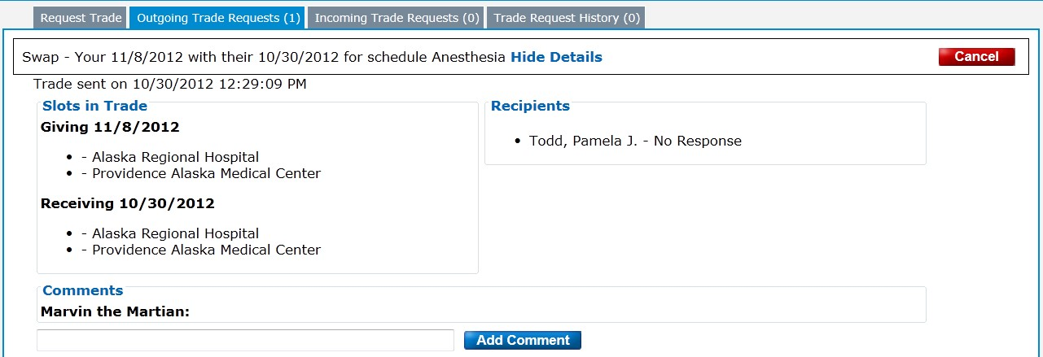

1. Click **Cancel** to cancel a request. To close the request without canceling, or to view another screen, click **View Details** or select another tab.

### Accept or Decline a Trade Request

Follow these steps to accept or decline a trade request:

1. Navigate to **Incoming Trade Requests** by performing one of the following actions:
   * Select the **Incoming Trade Requests** link From the **Home** screen. If there are any incoming trade requests, the system highlights the **Incoming Trade Requests** link in red.

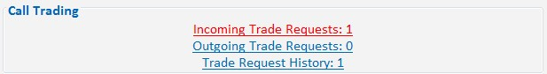

* + Select **Incoming Requests** on the **Call Trading** menu.
  + Select the **Incoming Trade Requests** tab from the **Call Trading** screen.

The system displays the **Incoming Trade** **Requests** tab of the **Call Trading** screen:

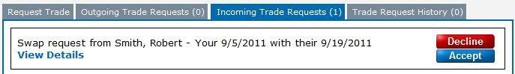

1. Click **View Details** to view the trade details:

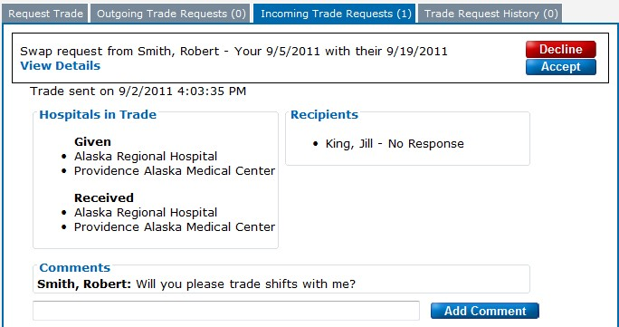

2. Click **Accept** or **Decline** to accept or decline the request.

* The trade initiator receives notification of the action via email.
* The request moves from **Incoming Trade Requests** to **Trade Request History**.
* The EMTALA schedule automatically updates the EMTALA shift if the request is accepted.

## Edit Provider Profile

A Provider Profile details a provider’s contact information, specialty, group, and whether or not the provider is exempt from EMTALA scheduling.

Follow these steps to edit provider information:

1. On the **Edit** menu, click **Provider Profile**. The system displays the user’s provider profile in **Edit Mode**:

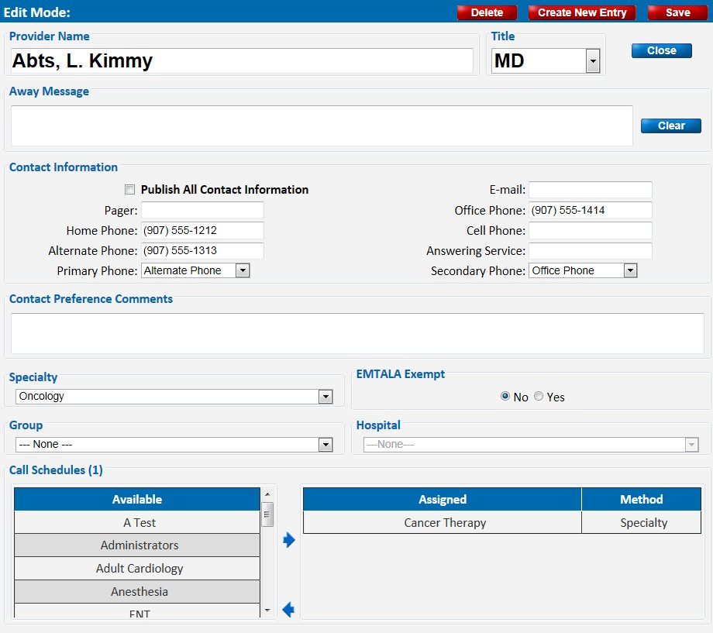

The areas that Provider users are able to edit include the following:

* + **Provider Name**
  + **Away Message**
  + **Publish All Contact Information** o Select the checkbox to allow all contact information to be visible to all other users.

o Unselect the checkbox to make only primary and secondary phone numbers visible to other users.

* + **Primary and Secondary Phone** o Select the phone or pager numbers to be used as primary and secondary contacts from the dropdown lists. These two mandatory numbers are visible to all users. • **Contact Preference Comments**

1. Modify profile information, and click **Save** in the top right corner. The system displays the **Save Successful** dialog box if the save is successful.

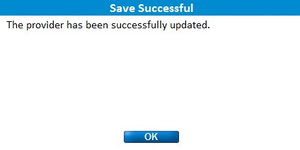

The system displays the **Invalid Entry** dialog box if the save is not successful.

## Change Password

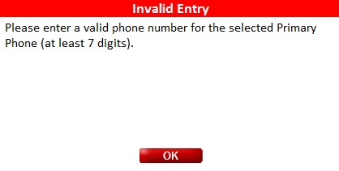

Providers may change their own passwords by following these steps:

1. On the **Admin** menu, click **Change Password**. The system displays the **Change Password** screen.

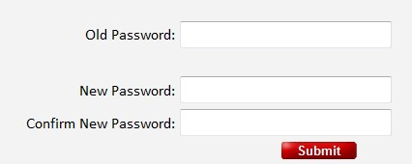

1. Enter the current password in **Old Password**, and enter the desired password in **New Password** and **Confirm New Password**.
2. Click **Submit** to save the new password. The system displays a success message if the change is successful:

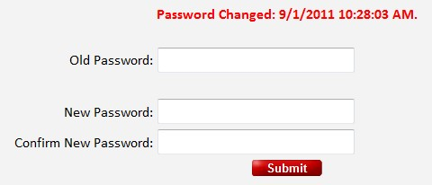

The system displays an error message if the save is not successful:

## View User Profile

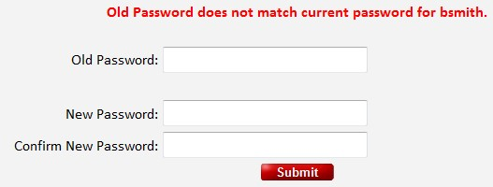

A User Profile details a user’s login information, roles, editing permissions, and contact information for system administrators. A user’s User Profile is visible to that user and the administrators only. Providers are not permitted to edit their User Profiles, but they may use the **Questions or Comments** link to request an update for any of this information.

Providers may view their own User Profiles by following these steps:

1. On the **Admin** menu, click **View User Profile**. The system displays the **View User Profile** screen:

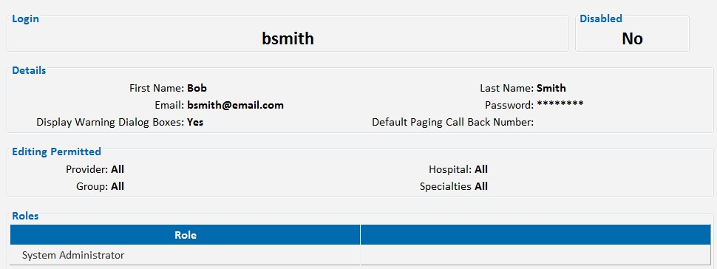

The information displayed on the **View User Profile** screen includes the following:

• **Details** o **Contact** **Information** o **Display Warning Dialog Boxes**

▪ Indicates whether or not the **Reminder** pop-up windows are displayed when navigating to edit screens. These dialogs remind the user that changes are not recorded until the **Save** button is clicked.

* **Editing Permitted** o Indicates which provider profile, group, hospital, or specialty the user is permitted to edit.
* **Roles**

o Lists all roles that the user belongs to.

# Tips, Tricks and Contacting Us.

**ALWAYS press the Save Button to save any changes you need saved!**

**The Blue menu bar at the top is your method to navigate around.**

Set your browser home page to <Http://www.calldrcentral.com>

This will allow you to quickly and easily launch the application.

Each browser is different:

IE – Click on the Gear Icon at the top right, Internet Options, and enter <http://www.calldrcentral.com> in the Homepage box, and click OK.

Chrome –

FireFox – Click on the FireFox option, upper left menu, and enter <http://www.calldrcentral.com> in the Homepage box and click OK.

Safari – (iMac) Click or Tap the Safari menu option, Preferences, and enter <http://www.calldrcentral.com> in the Homepage box then exit button.

Add a short cut on your desktop

Windows. Go to the Desktop. Right Click on the desktop. Select New. Select Short cut. Enter <http://www.calldrcentral.com>. Click Next. Enter a description for the short cut. Click ok. Short Cut will be on your desktop.

IMac – To be determined.

If you are on a shared computer, do not leave the application without logging out.

If you are on a shared computer, do not let the browser store your login information.

If your session times out, you will need to re-login.

If you make a mistake, you can use the back button on your browser to discard the changes, but once you press the Save button, you cannot undo the changes.

Verify that your email address is correct.

Verify that your phone number is correct.

**Tech Support**

If there is an issue or problem with the data that is in the system, please first call your application/database administrator. If the issue is not urgent, you can always leave us a message using the Questions or Comments link at the top right of the system. If the system is not working properly or you get an error that the web page cannot be found -

Call US!

1-907-248-2537